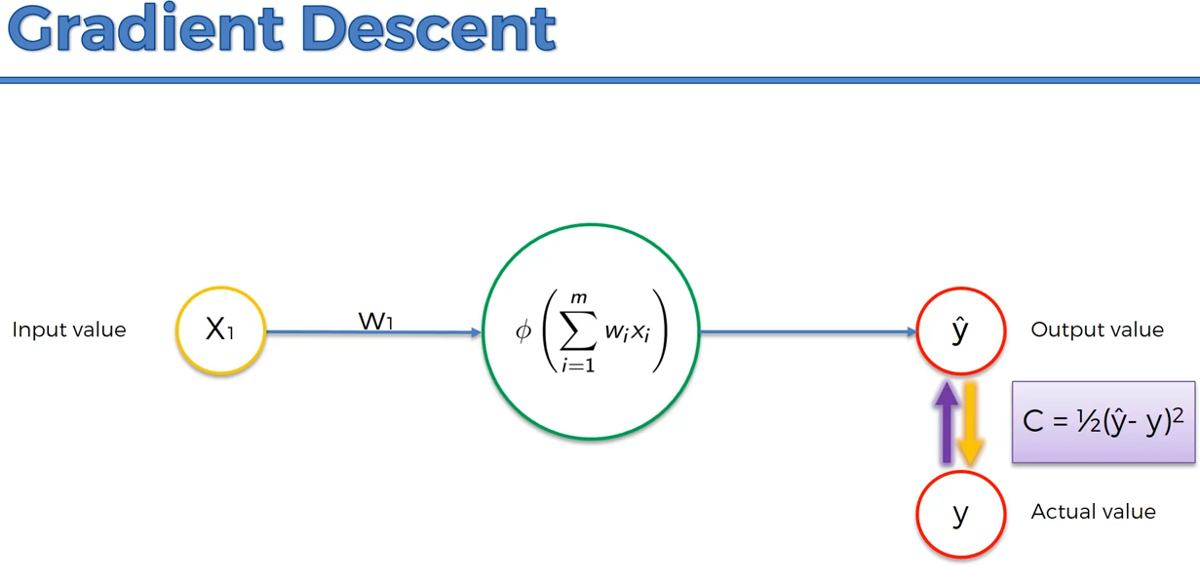

Gradient Descent is the method of finding the ideal ‘C’ or Sum Function value by Graphical representation of C of the data at every iteration/epoch.

Ex :-

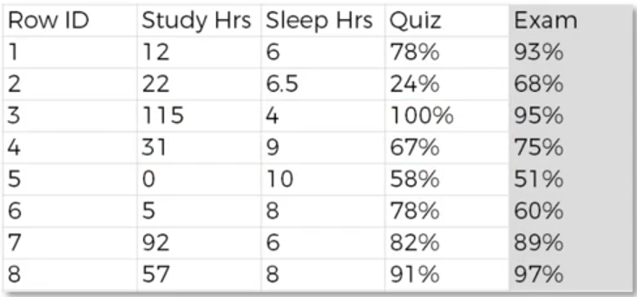

Let Imagine we are calculating the ‘C’ for every row and then, we are adjusting weight.

From above data, if we calculate ‘C’ then, we will get 8 ‘C’ Values. If we plot the graph of C values, it follows following graph.

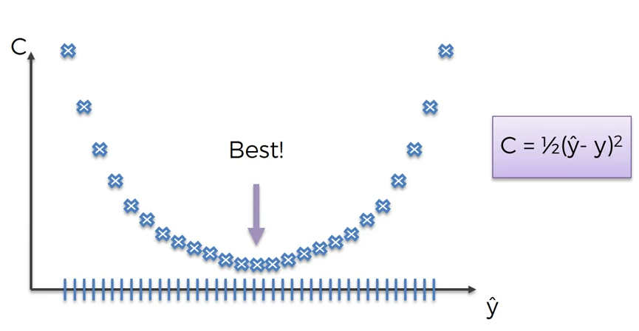

So, Where ‘C’ value is at it’s lowest point then, that point is Final point for C.

So, This lowest point is known as minima/ local Gradient Minima.

There are 2 types of Gradient Descent minima,

1. Local Gradient minima.
2. Global/ Stochastic Gradient minima.

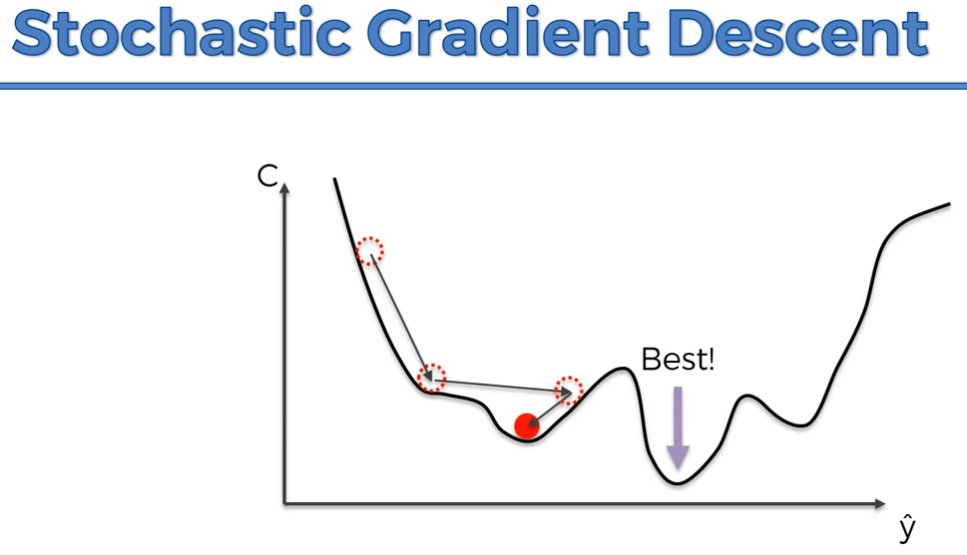

Here, We Assumed that, the least point is where the red ball is but actually the least point is at the next slope.

So, In this case, red ball position is known as local gradient minima whereas, Best lowest point is known as global gradient minima.

In neural network in every Iteration or epoch we focus to get the global minima instead of local minima.